**Использование Serial GC – Using Serial**

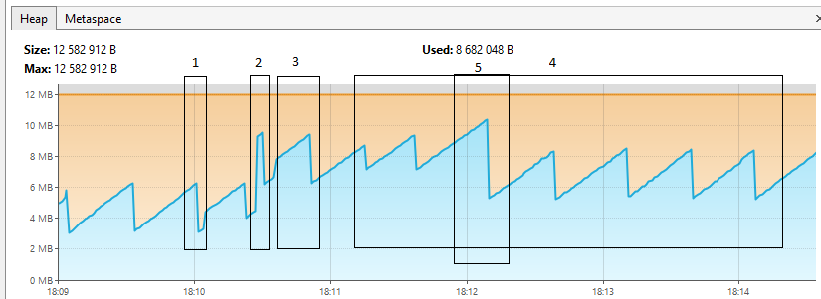

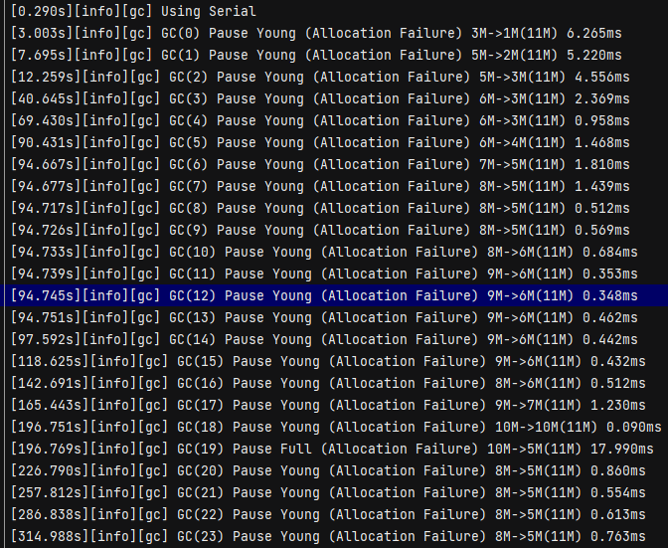

Обозначения на диаграмме:

1) заполнение созданного массива элементами

2) MergeSort: Начало сортировки - 18:10:26.891678200; Конец сортировки - 18:10:26.992684200

3) InsertSort: Начало сортировки - 18:10:35.261144; Конец сортировки - 18:10:46.251755200

4) BubbleSort: Начало сортировки - 18:11:14.925351700; Конец сортировки - 18:14:15.390390

5) момент максимального использования heap. В log-файле - Pause Full

**Использование Parallel GC**

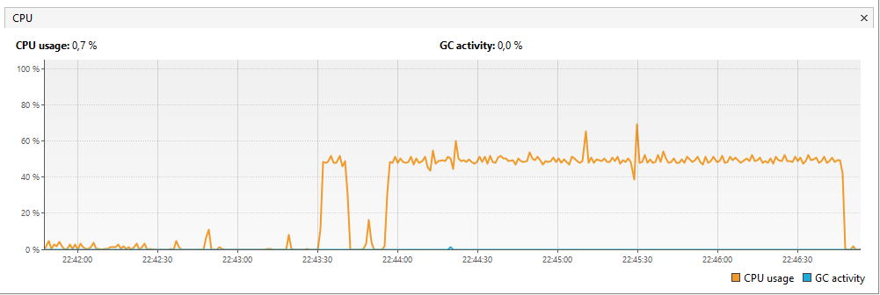

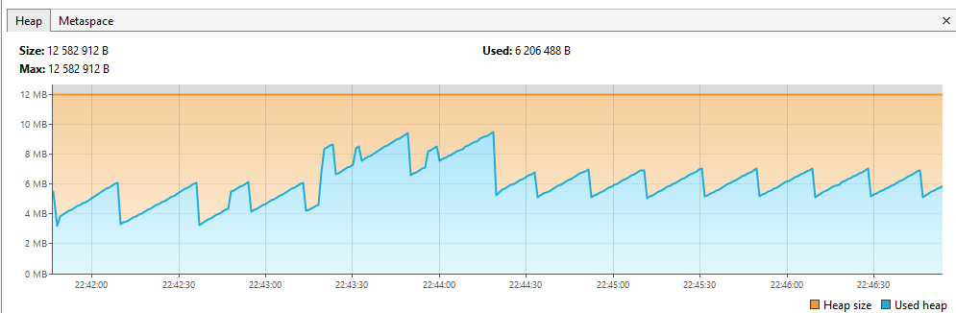

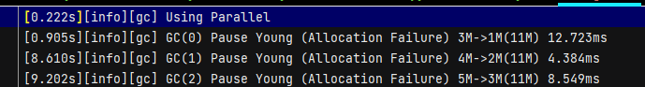

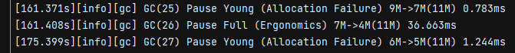

1) заполнение созданного массива элементами

2) MergeSort Начало сортировки - 22:43:18.990238200; Конец сортировки - 22:43:19.105244600

3) InsertSort Начало сортировки - 22:43:30.874899700; Конец сортировки - 22:43:40.712446700

4) BubbleSort Начало сортировки - 22:43:55.450266900; Конец сортировки - 22:46:46.778797100

5) момент максимального использования heap. В log-файле - Pause Full

InsertSort и BubbleSort наиболее затратные по использованию ресурсов процессора

**Использование** **G1GC**

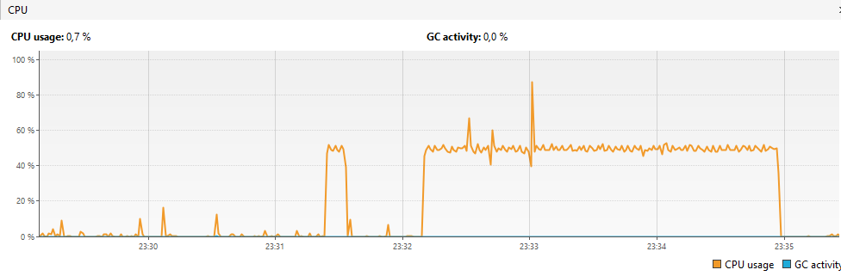

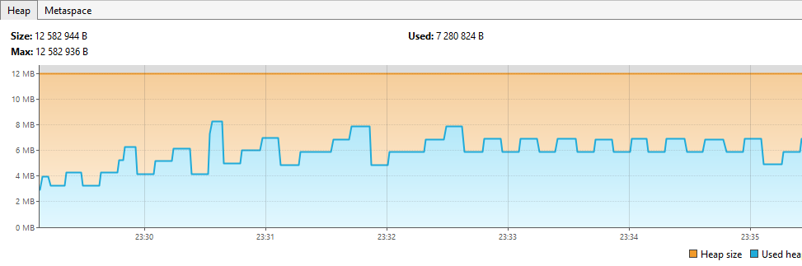

1) Заполнение созданного массива элементами;

2) MergeSort: Начало сортировки - 23:30:31.960839600; Конец сортировки - 23:30:32.083846

3) InsertSort: Начало сортировки - 23:31:23.224692900; Конец сортировки - 23:31:32.999234700

4) BubbleSort: Начало сортировки - 23:32:09.246252200; Конец сортировки - 23:34:57.051586400

[0.021s][info][gc] Using G1  
[7.105s][info][gc] GC(0) Pause Young (Normal) (G1 Evacuation Pause) 4M->2M(12M) 15.265ms  
[7.220s][info][gc] GC(1) Pause Young (Normal) (G1 Evacuation Pause) 3M->2M(12M) 6.902ms  
[7.356s][info][gc] GC(2) Pause Young (Normal) (G1 Evacuation Pause) 3M->2M(12M) 2.228ms  
[7.516s][info][gc] GC(3) Pause Young (Normal) (G1 Evacuation Pause) 4M->3M(12M) 3.382ms  
[11.619s][info][gc] GC(4) Pause Young (Normal) (G1 Evacuation Pause) 5M->3M(12M) 2.839ms  
[28.612s][info][gc] GC(5) Pause Young (Normal) (G1 Evacuation Pause) 5M->3M(12M) 1.978ms  
[54.673s][info][gc] GC(6) Pause Young (Normal) (G1 Evacuation Pause) 7M->4M(12M) 1.215ms  
[82.613s][info][gc] GC(7) Pause Young (Normal) (G1 Evacuation Pause) 7M->4M(12M) 1.162ms  
[91.405s][info][gc] GC(8) Pause Young (Normal) (G1 Evacuation Pause) 8M->5M(12M) 3.493ms  
[91.429s][info][gc] GC(9) Pause Young (Normal) (G1 Evacuation Pause) 7M->5M(12M) 2.479ms  
[91.447s][info][gc] GC(10) Pause Young (Normal) (G1 Evacuation Pause) 7M->5M(12M) 2.449ms  
[91.452s][info][gc] GC(11) Pause Young (Concurrent Start) (G1 Evacuation Pause) 7M->5M(12M) 1.876ms  
[91.453s][info][gc] GC(12) Concurrent Mark Cycle  
[91.461s][info][gc] GC(13) Pause Young (Normal) (G1 Evacuation Pause) 6M->5M(12M) 1.359ms  
[91.466s][info][gc] GC(12) Pause Remark 6M->6M(12M) 4.031ms  
[91.469s][info][gc] GC(14) Pause Young (Normal) (G1 Evacuation Pause) 6M->5M(12M) 0.545ms  
[91.471s][info][gc] GC(15) Pause Young (Normal) (G1 Evacuation Pause) 6M->5M(12M) 0.403ms  
[91.472s][info][gc] GC(12) Pause Cleanup 6M->6M(12M) 0.015ms  
[91.472s][info][gc] GC(12) Concurrent Mark Cycle 19.693ms  
[91.473s][info][gc] GC(16) Pause Young (Normal) (G1 Evacuation Pause) 6M->5M(12M) 0.415ms  
[91.479s][info][gc] GC(17) Pause Young (Concurrent Start) (G1 Evacuation Pause) 7M->5M(12M) 0.663ms  
[91.479s][info][gc] GC(18) Concurrent Mark Cycle  
[91.481s][info][gc] GC(19) Pause Young (Normal) (G1 Evacuation Pause) 6M->5M(12M) 0.484ms  
[91.483s][info][gc] GC(20) Pause Young (Normal) (G1 Evacuation Pause) 6M->5M(12M) 0.231ms  
[91.485s][info][gc] GC(21) Pause Young (Normal) (G1 Evacuation Pause) 6M->6M(12M) 0.255ms  
[91.488s][info][gc] GC(22) Pause Young (Normal) (G1 Evacuation Pause) 6M->6M(12M) 0.274ms  
[91.492s][info][gc] GC(18) Pause Remark 6M->6M(12M) 2.844ms  
[91.496s][info][gc] GC(23) Pause Young (Normal) (G1 Evacuation Pause) 8M->6M(12M) 0.353ms  
[91.497s][info][gc] GC(18) Pause Cleanup 6M->6M(12M) 0.017ms  
[91.497s][info][gc] GC(18) Concurrent Mark Cycle 18.059ms  
[91.500s][info][gc] GC(24) Pause Young (Normal) (G1 Evacuation Pause) 8M->6M(12M) 0.289ms  
[91.505s][info][gc] GC(25) Pause Young (Concurrent Start) (G1 Evacuation Pause) 8M->6M(12M) 0.902ms  
[91.505s][info][gc] GC(26) Concurrent Mark Cycle  
[91.509s][info][gc] GC(27) Pause Young (Normal) (G1 Evacuation Pause) 8M->6M(12M) 0.371ms  
[91.515s][info][gc] GC(26) Pause Remark 8M->8M(12M) 1.472ms  
[91.533s][info][gc] GC(26) Pause Cleanup 8M->8M(12M) 8.060ms  
[91.533s][info][gc] GC(26) Concurrent Mark Cycle 28.322ms  
[97.714s][info][gc] GC(28) Pause Young (Normal) (G1 Evacuation Pause) 9M->5M(12M) 0.923ms  
[126.616s][info][gc] GC(29) Pause Young (Normal) (G1 Evacuation Pause) 8M->4M(12M) 0.600ms  
[142.661s][info][gc] GC(30) Pause Young (Concurrent Start) (G1 Humongous Allocation) 6M->4M(12M) 1.238ms  
[142.661s][info][gc] GC(31) Concurrent Undo Cycle  
[142.661s][info][gc] GC(31) Concurrent Undo Cycle 0.124ms  
[170.822s][info][gc] GC(32) Pause Young (Normal) (G1 Evacuation Pause) 8M->4M(12M) 0.616ms  
[188.682s][info][gc] GC(33) Pause Young (Concurrent Start) (G1 Humongous Allocation) 6M->4M(12M) 2.075ms  
[188.682s][info][gc] GC(34) Concurrent Undo Cycle  
[188.682s][info][gc] GC(34) Concurrent Undo Cycle 0.089ms  
[216.889s][info][gc] GC(35) Pause Young (Normal) (G1 Evacuation Pause) 8M->5M(12M) 0.606ms  
[235.910s][info][gc] GC(36) Pause Young (Concurrent Start) (G1 Evacuation Pause) 7M->5M(12M) 0.864ms  
[235.910s][info][gc] GC(37) Concurrent Mark Cycle  
[235.921s][info][gc] GC(37) Pause Remark 5M->5M(12M) 1.810ms  
[235.926s][info][gc] GC(37) Pause Cleanup 5M->5M(12M) 0.024ms  
[235.926s][info][gc] GC(37) Concurrent Mark Cycle 16.196ms  
[254.690s][info][gc] GC(38) Pause Young (Normal) (G1 Evacuation Pause) 7M->5M(12M) 0.836ms  
[272.954s][info][gc] GC(39) Pause Young (Concurrent Start) (G1 Evacuation Pause) 7M->5M(12M) 0.765ms  
[272.954s][info][gc] GC(40) Concurrent Mark Cycle  
[272.966s][info][gc] GC(40) Pause Remark 5M->5M(12M) 1.867ms  
[272.971s][info][gc] GC(40) Pause Cleanup 5M->5M(12M) 0.030ms  
[272.971s][info][gc] GC(40) Concurrent Mark Cycle 17.219ms  
[291.029s][info][gc] GC(41) Pause Young (Normal) (G1 Evacuation Pause) 7M->5M(12M) 0.792ms  
[308.005s][info][gc] GC(42) Pause Young (Concurrent Start) (G1 Evacuation Pause) 7M->5M(12M) 0.895ms  
[308.005s][info][gc] GC(43) Concurrent Mark Cycle  
[308.018s][info][gc] GC(43) Pause Remark 6M->6M(12M) 2.047ms  
[308.023s][info][gc] GC(43) Pause Cleanup 6M->6M(12M) 0.029ms  
[308.023s][info][gc] GC(43) Concurrent Mark Cycle 17.790ms  
[327.030s][info][gc] GC(44) Pause Young (Normal) (G1 Evacuation Pause) 7M->5M(12M) 0.688ms  
[346.051s][info][gc] GC(45) Pause Young (Concurrent Start) (G1 Evacuation Pause) 7M->5M(12M) 0.768ms  
[346.051s][info][gc] GC(46) Concurrent Mark Cycle  
[346.064s][info][gc] GC(46) Pause Remark 6M->6M(12M) 1.882ms  
[346.068s][info][gc] GC(46) Pause Cleanup 6M->6M(12M) 0.027ms  
[346.068s][info][gc] GC(46) Concurrent Mark Cycle 17.177ms  
[365.080s][info][gc] GC(47) Pause Young (Normal) (G1 Evacuation Pause) 7M->4M(12M) 0.737ms